AI LOAN ELIGIBILITY CHECKER

Project Documentation

AI-Powered BFSI Web Platform for Loan Eligibility, Credit Analysis, EMI Planning and Financial Guidance
Project Description
FinAI– AI Loan Eligibility Checker is an AI-powered BFSI web platform designed to help users understand their financial position and make informed decisions related to loans and personal finance.
The platform combines multiple financial tools into a single web interface, including a Loan Eligibility Checker, Credit Score Analyzer, EMI Calculator and AI Financial Tips. It allows users to enter their financial information and receive calculated results, financial insights and educational guidance.
The Loan Eligibility Checker evaluates information such as age, employment type, monthly income, existing EMIs, credit score, requested loan amount, loan tenure, employment duration and estimated monthly expenses. Based on these inputs, the system provides an estimated eligibility result and financial indicators.
The Credit Score Analyzer helps users understand their credit position by analyzing the entered credit score and related credit factors. The EMI Calculator calculates the estimated monthly EMI, total interest and total payable amount based on the loan amount, interest rate and tenure.
The AI Financial Tips module provides personalized educational financial guidance based on the user's financial information and questions.
The project uses HTML, CSS and JavaScript for the frontend, with Python Flask REST API for backend services, Claude AI for AI-based assistance and Google Sheets / local storage for data management.

Project Scenarios

Scenario 1: Loan Eligibility Assessment
A user enters personal, employment and financial information such as age, employment type, monthly income, existing EMI, credit score, requested loan amount and loan tenure. The system processes the information and provides an estimated eligibility result, EMI burden and risk level.
Scenario 2: Credit Score Analysis
A user enters their credit score and supporting credit information. The system analyzes the score and displays the corresponding credit category along with factors that can affect credit health.
Scenario 3: EMI Planning
A user enters the loan amount, interest rate and repayment tenure. The system calculates the estimated monthly EMI, total interest and total payable amount.
Scenario 4: AI Financial Guidance
A user can ask financial questions or select predefined prompts. The AI Financial Tips module provides educational guidance related to loans, credit scores, EMI and personal finance.
Scenario 5: Financial Dashboard Review
The user can access the available financial tools from one centralized interface and review the results generated by the different modules.

System Architecture
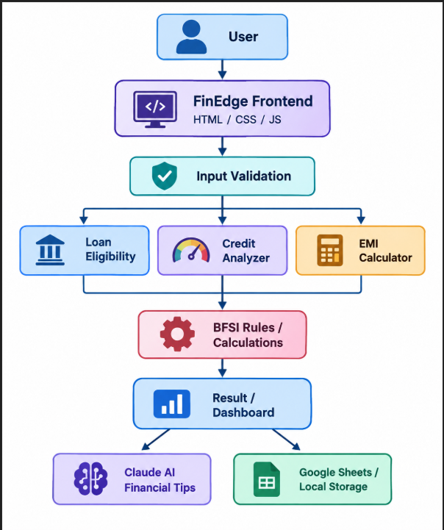

High-Level Flow
User → Web Interface → Input Validation → Financial Calculation/AI Request → Result → Dashboard/Activity.

Project Workflow

Milestone 1: Requirement Analysis and Architecture
- Identify the financial problem and user requirements.
- Define the major financial modules.
- Design the interaction between frontend, backend, AI service and storage.
- Define the overall system architecture.
Milestone 2: Core Financial Features
- Implement loan eligibility input collection.
- Develop eligibility calculation logic.
- Implement credit score analysis.
- Develop EMI calculation.
- Generate financial results and indicators.
Milestone 3: AI Integration
- Integrate Claude AI for financial assistance.
- Create AI Financial Tips functionality.
- Add predefined financial prompts.
- Handle AI responses and fallback behavior.
Milestone 4: Frontend Development
- Develop responsive HTML pages.
- Create forms and input fields.
- Implement navigation between modules.
- Apply the dark glassmorphism design.
- Add cards, buttons, indicators and interactive components.
Milestone 5: Testing and Deployment
- Test different financial inputs.
- Verify calculations.
- Test validation and error handling.
- Test AI functionality.
- Deploy the web application for online access.
This follows the same milestone-based organization used in your reference documentation.

Module 1 – Home / Landing Page
The Home page introduces the FinEdge AI Loan Eligibility Checker and provides access to the major financial tools.
Main Elements
- Project introduction and purpose.
- Navigation menu.
- Loan Eligibility Checker.
- Credit Score Analyzer.
- EMI Calculator.
- AI Financial Tips.
- Get Started / tool access buttons.
- Financial tool cards.
- Responsive user interface.
User Flow
Home
↓
Select Financial Tool
↓
Enter Financial Details
↓
Process Information
↓
View Result

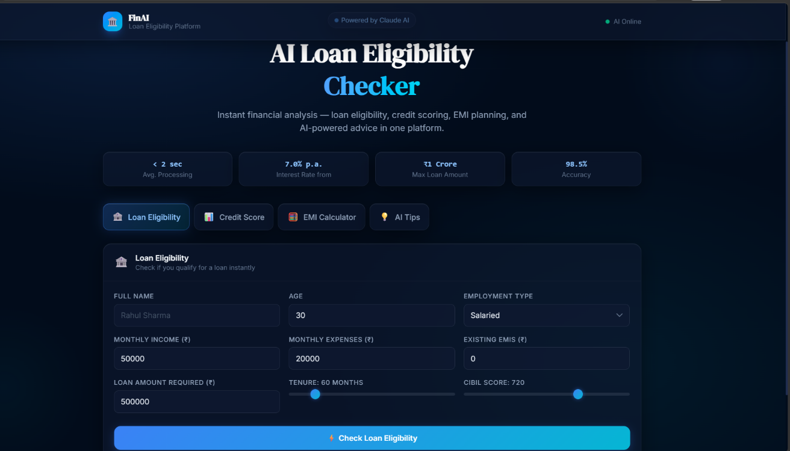
"Make Smarter Financial Decisions with AI"

Module 2 – Loan Eligibility Checker

The Loan Eligibility Checker is the main module of the project. It collects personal, employment and financial information and processes the entered values to estimate the user's loan eligibility.
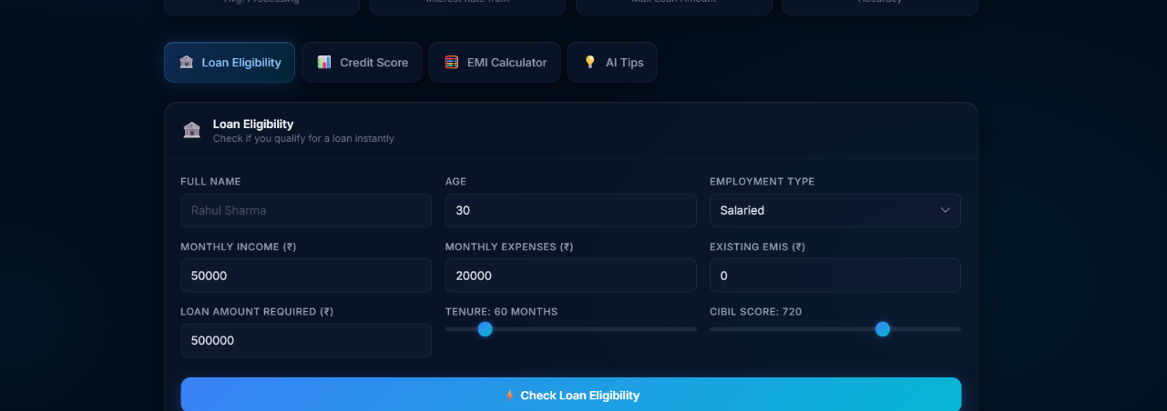

Module 3 – Credit Score Analyzer
The Credit Score Analyzer allows users to enter and analyze their credit score and related financial information.
The module presents the credit score and provides information that helps users understand their credit position.
Credit Score Categories
You can use the same project-defined ranges shown in the reference documentation:
Score Range | Category
800–900 | Excellent
740–799 | Very Good
670–739 | Good
600–669 | Fair
300–599 | Poor
Analyzed Factors
- Credit card utilization
- Payment history
- Recent credit inquiries
- Active loans
- Active credit cards
- Outstanding debt
These factors are also listed in the reference documentation.
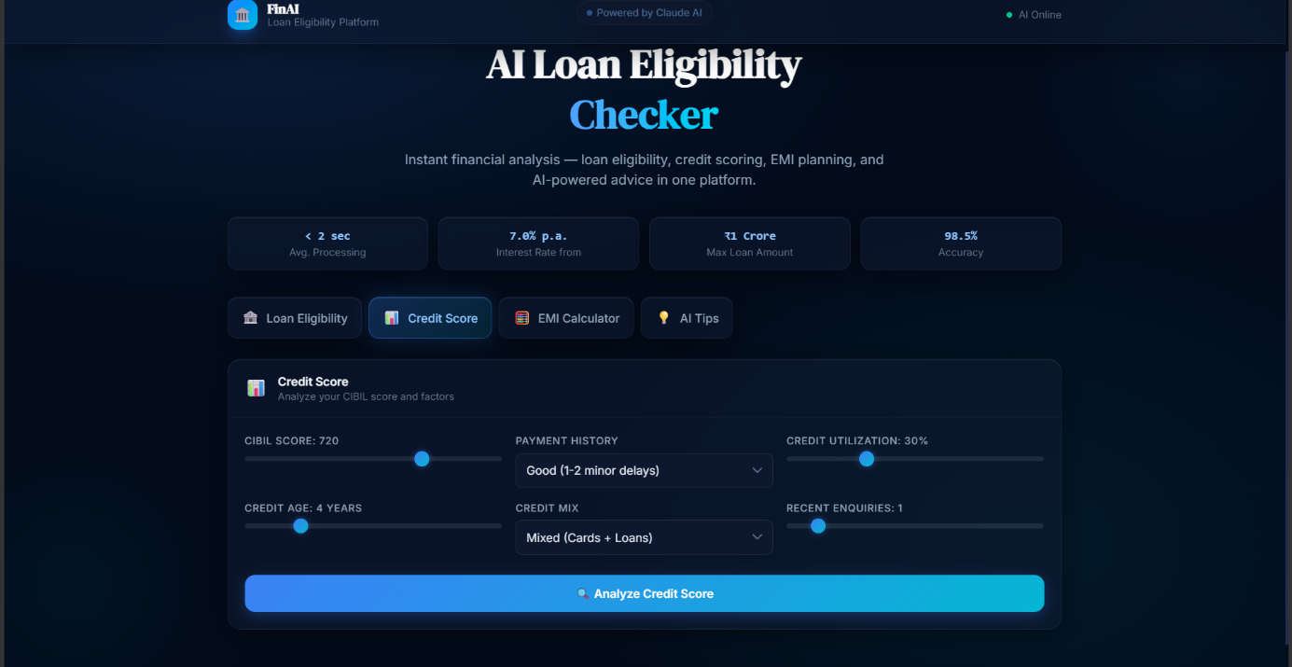

Module 4 – EMI Calculator
The EMI Calculator helps users estimate their monthly loan repayment based on the principal amount, annual interest rate and loan tenure.
Main Inputs
- Loan Amount
- Annual Interest Rate
- Loan Tenure
Main Outputs
- Monthly EMI
- Total Principal
- Total Interest
- Total Payable Amount
- Loan Repayment Breakdown
Formula
EMI = P × R × (1 + R)^N
---------------------
(1 + R)^N − 1
Where:
- P = Principal loan amount
- R = Monthly interest rate
- N = Total number of monthly installments
This is the same EMI formula used in the reference documentation.
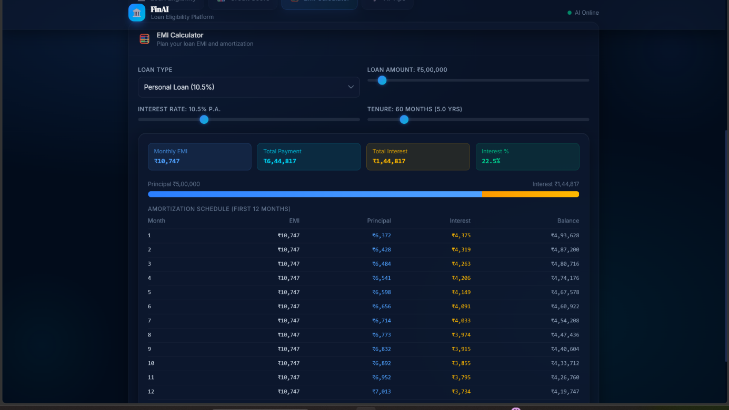.

Module 5 – AI Financial Tips
The AI Financial Tips module provides users with AI-powered educational financial guidance.
Users can enter a financial question or use predefined prompts to receive relevant information related to loans, credit scores, EMI planning and personal finance.
Example Questions
- How can I improve my credit score?
- Can I afford this loan?
- How can I reduce my EMI?
- How can I manage my monthly expenses?
- Give me general financial guidance.

Fallback Mechanism
If the AI service is unavailable, the application can use predefined educational responses for common financial topics so that the module remains usable during demonstration.
The reference documentation describes the same AI-request and fallback concept
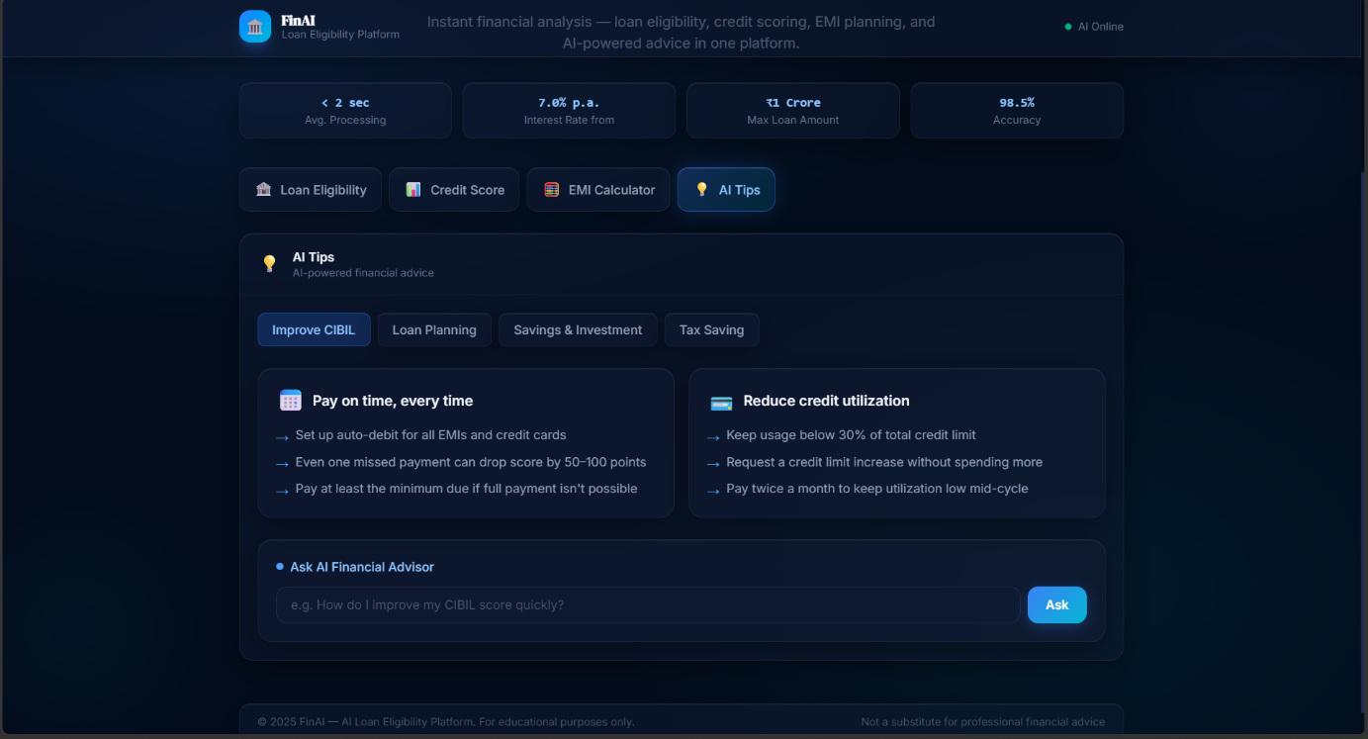

Module 6: Financial Dashboard / Tools Dashboard

The dashboard provides a centralized interface through which users can access the major financial tools.
Main Financial Tools
- Loan Eligibility Checker
- Credit Score Analyzer
- EMI Calculator
- AI Financial Tips
Dashboard Functions
- Access financial tools.
- View financial information.
- Start a loan eligibility assessment.
- Analyze credit score.
- Calculate EMI.
- Get AI financial guidance.
Four Essential Financial Tools in One Dashboard
.

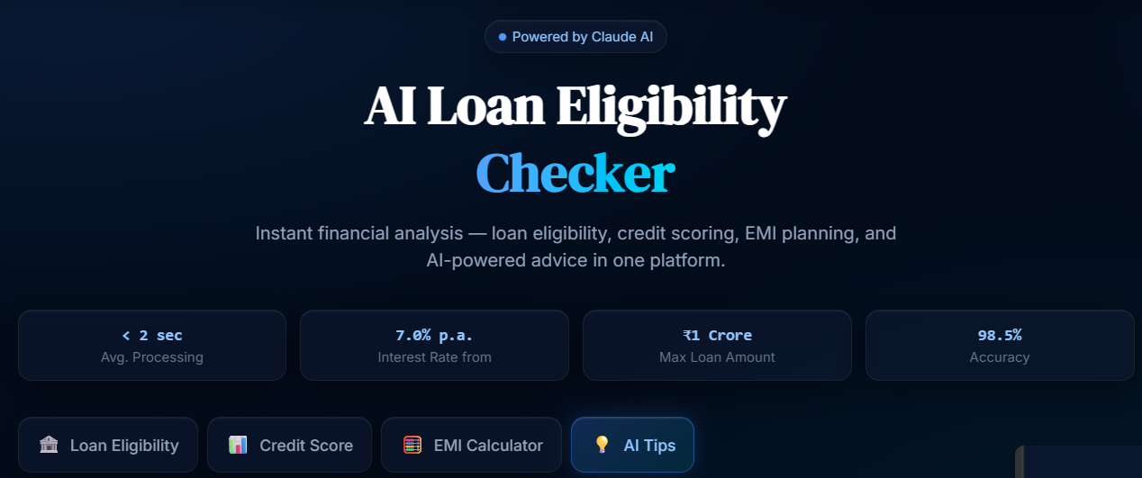
with the four cards:
- Loan Eligibility
- Credit Score Analyzer
- EMI Calculator
- AI Financial Tips
This is perfect for this section

Data Flow and API Integration
Data Flow

User Input
↓
HTML Form
↓
JavaScript Validation
↓
Financial Processing
↓
Eligibility / Credit / EMI Result
↓
Dashboard / Result Display
↓
Data Storage

AI Integration Flow

AI Financial Question
↓
Frontend
↓
Backend API
↓
Claude AI
↓
AI Response
↓
Financial Tips Interface

Data Storage :
The application can store relevant user/assessment information through the configured data-storage mechanism such as Google Sheets / local storage.
Technologies
- HTML
- CSS
- JavaScript
- Python Flask
- Claude AI
- Google Sheets / Local Storage
The reference documentation describes separate storage and AI endpoints and flow connecting assessment, processing, dashboard and AI services.

Structure :
Project Structure
You can write your project structure like this:
FinEdge/
│
├── index.html
├── style.css
├── script.js
│
├── backend/
│ ├── app.py
│ └── requirements.txt
│
├── config/
│ └── .env.example
│
└── README.md
File Description
index.html
Contains the main structure of the web application, including navigation, forms, financial tools and result sections.
style.css
Controls the visual appearance, layout, colors, buttons, cards, responsive design and glassmorphism interface.
script.js
Handles user interaction, validation, calculations, navigation, financial processing and AI-related frontend functionality.
backend/app.py
Handles backend/API-related operations and communication between the frontend and external services.
requirements.txt
Contains the Python packages required by the backend.
.env.example
Contains the template for configuration values such as API keys and other environment variables.
README.md
Contains project information, setup instructions, technologies and usage details.
The reference document uses the same file-by-file explanation approach.

User Interface and Design :
The FinEdge application uses a modern dark glassmorphism-inspired design to provide a clean and interactive financial interface.
Design Principles
- Dark background for a modern appearance.
- Glassmorphism-style cards.
- Clear navigation.
- Responsive layout.
- Interactive buttons and forms.
- Financial result cards.
- Clear status indicators.
- Consistent typography and spacing.
- User-friendly financial tools.
Responsive Design
The interface is designed to adapt to different screen sizes, allowing users to access the financial tools from desktop and smaller screens.
The reference documentation similarly describes dark glassmorphism styling, cards, status indicators, responsive layouts and interactive controls.

Testing Strategy :

Functional Testing
- Check required fields.
- Check invalid numerical values.
- Verify loan eligibility results.
- Verify credit score analysis.
- Verify EMI calculations.
- Verify AI Financial Tips functionality.
- Verify navigation between modules.
- Verify result display.

Boundary Testing
Test different values such as:
- Minimum and maximum age.
- Very low and high income.
- Different credit score values.
- Different loan amounts.
- Different loan tenures.
- Different existing EMI values.
- Different employment durations.

Non-Functional Testing
- Responsiveness
- Usability
- Error handling
- Performance
- API security
- Input validation
- Data handling
These testing categories closely follow the reference documentation's functional, boundary and non-functional testing organization.

Deployment :
After completing the development of the website, the project files can be uploaded to a GitHub repository for version control.
The repository can then be connected to a suitable cloud deployment platform such as Vercel or another supported hosting service.
After successful deployment, the application receives a public URL through which users can access the website.

Execution :
The deployed website can be opened through a web browser.
Users can:
- Open the FinEdge website.
- Access the Loan Eligibility Checker.
- Enter financial information.
- Check estimated eligibility.
- Analyze credit score.
- Calculate EMI.
- Use AI Financial Tips.
- Review financial information through the dashboard/tools interface.
Your reference documentation describes the same GitHub → deployment platform → public website flow.
Conclusion:
FinEdge – AI Loan Eligibility Checker combines loan eligibility assessment, credit score analysis, EMI calculation and AI-based financial guidance into a single web-based BFSI platform.
The system provides users with an easy way to enter financial information, calculate loan-related values, understand their credit position and receive educational financial guidance.
The modular architecture makes it possible to access different financial tools from one centralized interface. The project demonstrates the practical integration of HTML, CSS, JavaScript, Python Flask, AI services and data storage in a financial technology application.
Overall, the project demonstrates how modern web technologies and AI can be combined to create an interactive financial assistance platform for educational and demonstration purposes.

